***EE2023/TEE2023/EE2023E TUTORIAL 6 (PROBLEMS)***

***Section I : Exercises that are straightforward applications of the concepts covered in class. Please attempt these problems on your own.***

1. Consider the following transfer function :



(a) Write down the differential equation relating *y*(*t*) and *x*(*t*). What values should the output signal (initial conditions) assume when *t* = 0 for the transfer function to hold?



Answer :

(b) Suppose *x*(*t*) is a step function of magnitude 2. Determine the steady-state value of *y*(*t*)

* by performing inverse Laplace Transform.
* using the Final Value Theorem.

Answer : Steady-state value of

2. According to the convolution theorem, the unit step response of a system is



where *u*(*t*) is the unit step function. What is the system transfer function?



Answer :

***Section II – Problems that will be discussed in class.***

1. Consider the electrical circuit shown in Figure 1. Derive the transfer function , where

 And . The assumptions made in the derivation of the transfer function should be clearly stated.

Answer :

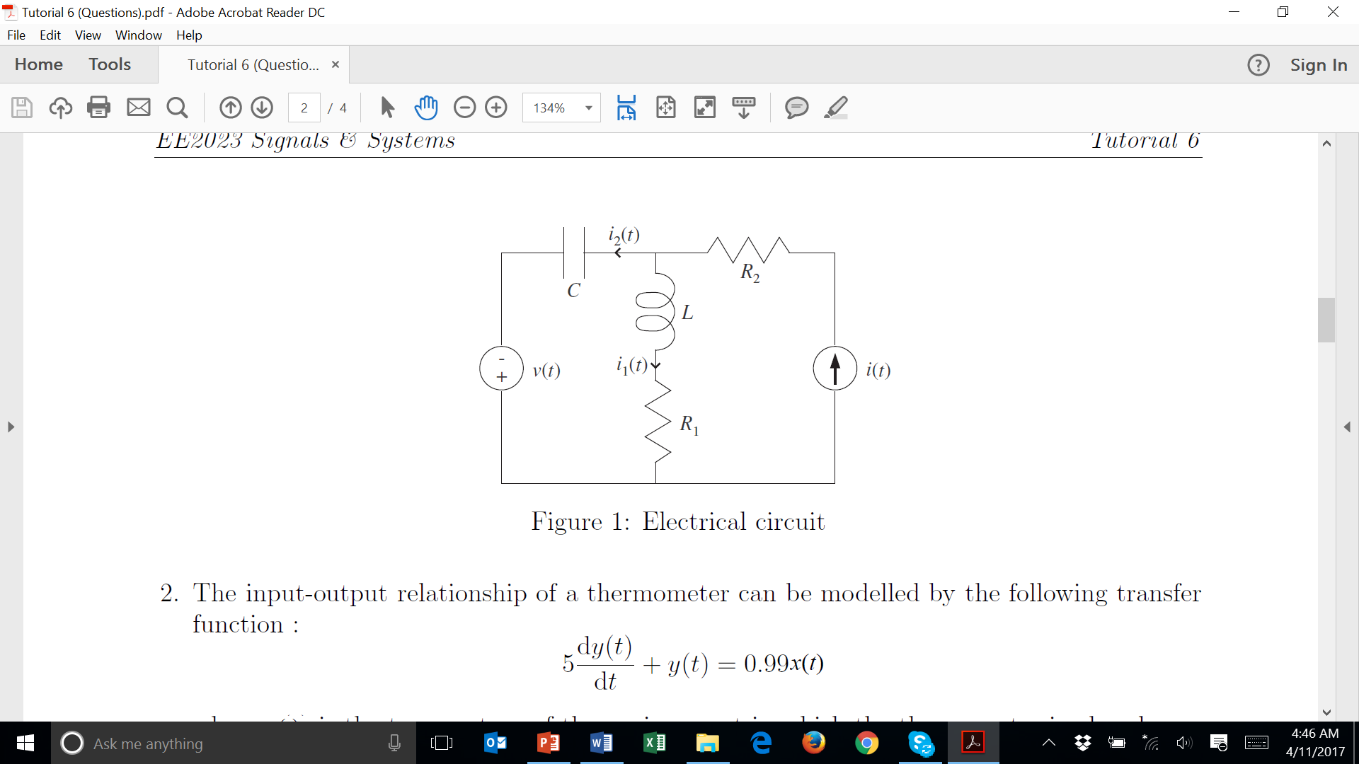

2. The input-output relationship of a thermometer can be modelled by the following transfer function:



where *x*(*t*) is the temperature of the environment in which the thermometer is placed, and *y*(*t*) is the measured temperature.

The thermometer is inserted into a heat bath maintained at a constant temperature and the thermometer reading is allowed to stabilise before the temperature of the water in the heat bath is increased at a steady rate of 1oC/second.

(a) Suppose the measured temperature is 24.75oC when *t* = 0, i.e. *y*(0) = 24:75oC. What is the temperature of the heat bath?

Answer : *x*(0) = 25oC

(b) Write a mathematical expression to represent the temperature in the heat bath, *x*(*t*). Then, solve the differential equation to obtain the time-domain expression for the measured temperature, *y*(*t*).

Answer :

(c) What is the transfer function representation of the thermometer?



Answer :

(d) Let  and . Derive the time domain expression for the measured temperature, *y*(*t*), using the transfer function of the thermometer obtained in part (c).

3. For the following linear time-invariant continuous time systems, determine if the system is BIBO stable, marginally stable or unstable.

(a) Transient response is *e-t* + *e*2*t* for *t* ≥ 0.

(b) Transient response is sin(2*t*) for t ≥ 0.

(c) Transient response is *e-t* sin(2*t*) for t ≥ 0.



(d) Differential equation representation is



(e) Transfer function is



(f) Transfer function is



(g) Transfer function is



(h) System response is when the input signal is the ramp function, *t*.

Answer : (a) Unstable; (b) Marginally stable; (c) Stable; (d) Unstable; (e) Marginally stable; (f) Unstable; (d) Stable; (h) Stable

4. The behaviour of an air heating system may be described by the following differential equation :



where *h*(*t*) is the heat input (system input), *R* is the thermal resistance, and *C* is the thermal capacitance.

Figure 2 shows the outlet air temperature, *θ*o(*t*), when the system input is an unit impulse function, i.e. *h*(*t*) = *δ*(*t*), under zero initial conditions.



(a) Show that the unit impulse response of the air heating system is

(b) From Figure 2, estimate the thermal resistance, *R*, and the thermal capacitance, *C*, of the air heating system.

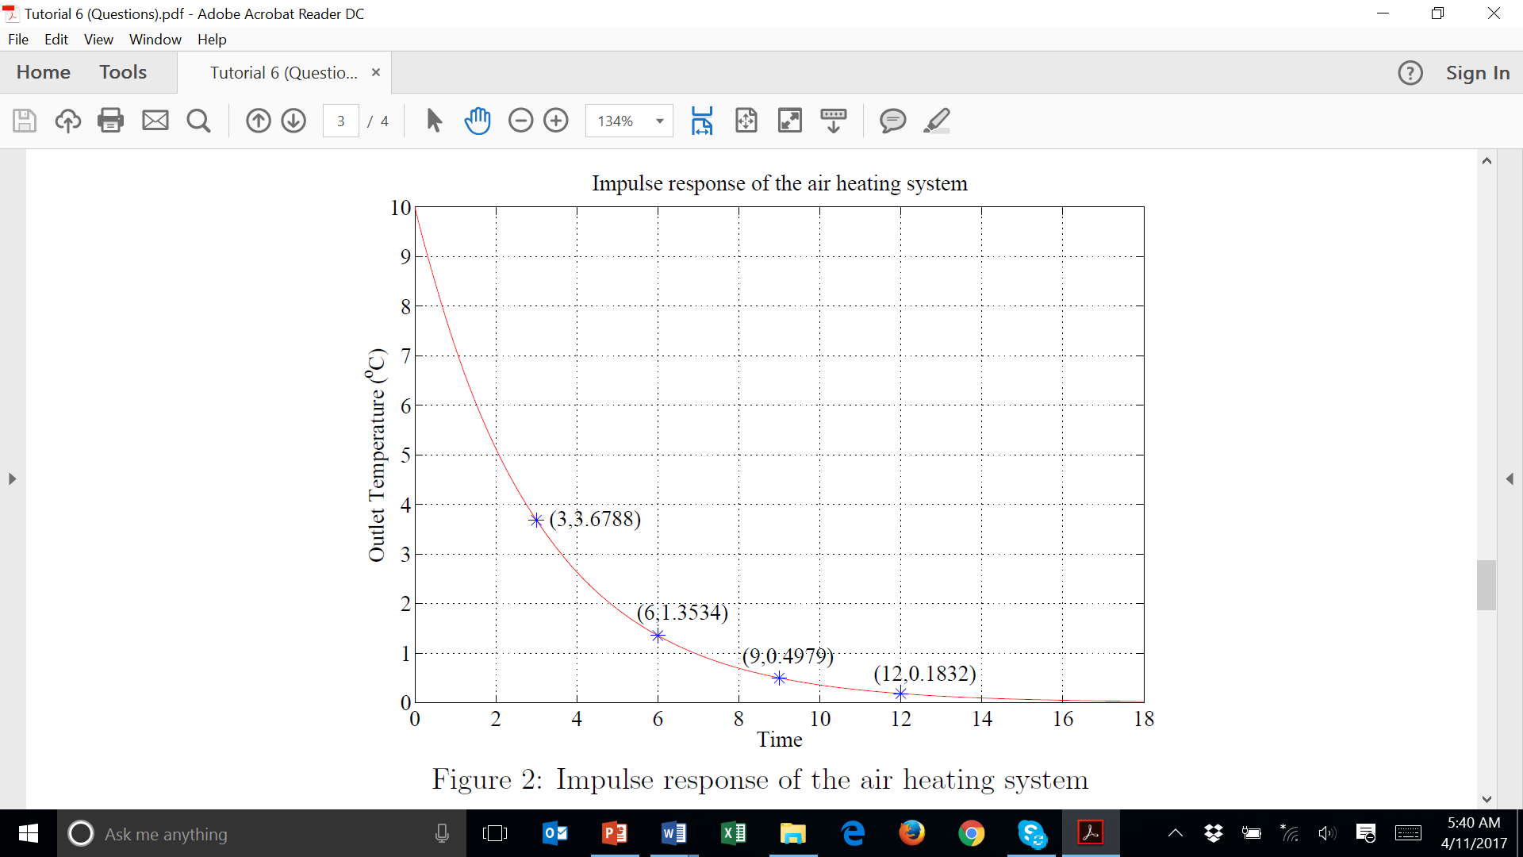

***Section III : Practice Problems. These problems will not be discussed in class.***

1 Consider the electrical circuit shown in Figure 1. Derive the transfer function and

 , where .



Answer :



2. Let the input signal, output signal and transfer function of a system be *x*(*t*), *y*(*t*) and *G*(*s*) respectively. When the input signal is a step function of magnitude 4,



* the steady-state output signal, is 8, and
* the poles of are *s* = 0; -3; -7 ± 5j.

What is the system transfer function *G*(*s*)? Is the system stable, marginally stable or unstable?



Answer : , Stable